**Elevator Control System Use Case**

**Primary Actor:** Elevator User

Scope: Elevator Usage Process

Level: User goal

Stakeholders and Interests:

* Elevator User: wants safe and reliable use of the elevator
* Building Staff: wants to assist the elevator user to have an overall good experience with building facilities

**Precondition:**

* The elevator is installed correctly and operational
* Power to the building is supplied
* The elevator is not currently under maintenance

Minimal guarantee:

* The elevator responds to user commands such as selecting floors and opening/closing doors when powered and not under maintenance

**Success guarantee:**

* Users can enter the elevator, select desired floors, and exit the elevator safely and efficiently

**Main Success Scenario:**

1. User enters the elevator lobby and waits for the elevator
2. User enters the selected elevator and selects the desired floor using the control panel
3. Elevator doors close, and the elevator moves to the selected floor
4. Elevator doors open at the selected floor, and the user exits

**Extensions:**

1a. Elevator cabin exceeds maximum capacity

1a1. Users exit the elevator and wait for the next available cabin.

1b. Users with mobility challenges experience difficulty

1b1. Users press the 'assistance' button or use the intercom to request assistance.

1b2. Building staff provides necessary assistance to the user.

2a. Power outage occurs while in the elevator

2a1. Emergency lights and communications systems activate.

2a2. Users are informed of the situation and advised to stay calm and wait for assistance.

2b. Elevator stops moving during transit

2b1. Users press the emergency button or call for help using the intercom.

2b2. Users are informed about the situation and advised to wait for assistance.

2c. Control panel/buttons do not respond

2c1. Users try pressing the button again.

2c2. If unsuccessful, users use the emergency communications system.

2d. Mechanical failure occurs (e.g. door jam)

2d1. Users press the emergency button or call for help using the intercom.

2d2. Users are informed about the situation and advised to wait for assistance

**UML Class Diagram**

**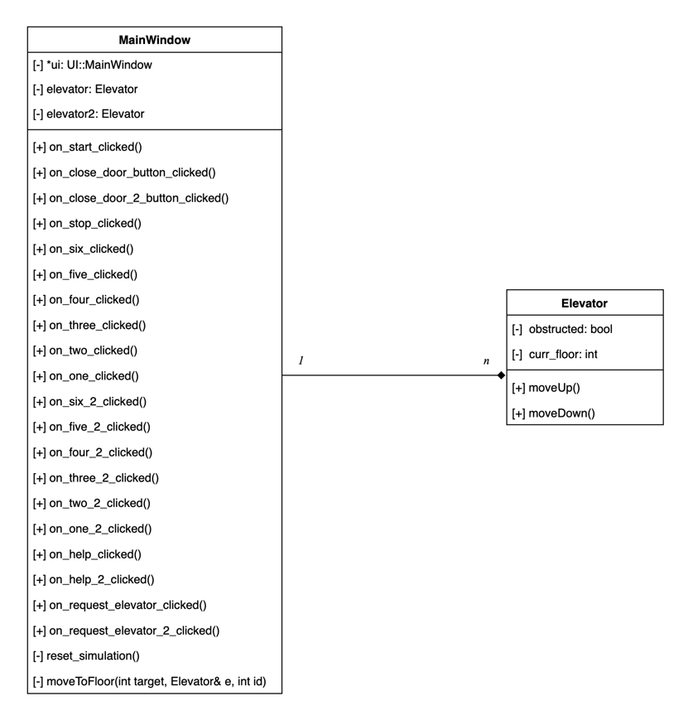  
  
Sequence Diagrams – Success Cases**

**Sequence Diagrams – Safety Cases**

Capacity Reached:

Accessibility Issue:

Power Outage:

Door Doesn’t Open:

Fire:

**State Diagram**

**Textual Explanation**

In designing the elevator system, the primary objective was to capture core functionalities and user interactions, with a focus on modularity and clarity. The UML sequence diagrams showcase the dynamic behavior of the system through five distinct scenarios: a regular passenger's journey, simultaneous requests by two passengers, overloading, handling of passengers with special needs, and updates on the display system. Notably, certain peripheral classes or entities might appear in more comprehensive diagrams to offer an in-depth view; however, these were omitted here to prioritize central functionalities and maintain brevity. The design decisions were grounded in established software design patterns, ensuring both scalability and ease of understanding.

For the state diagram, initially at an idle state, the system awaits user input. When a passenger chooses a floor, the system determines the direction, either moving up or down based on the user's selection. As the elevator nears the desired floor, it ceases movement, opens the door allowing the passenger to exit, and then promptly shuts the door. Should the elevator exceed its capacity or encounter malfunctions, fire, or a power outage, it defaults to emergency procedures. Once all immediate tasks are managed, the system processes any queued requests, before reverting to its idle state, ready for the next operation.

**Traceability Matrix**

|  |  |  |  |  |  |  |  |
| --- | --- | --- | --- | --- | --- | --- | --- |
| ID | Requirement | Related Use Case | Fulfilled By | Test | Description | Implemented By | Tested By |
| 1 | Elevator responds to user commands | Main Success Scenario | Elevator Control System | Test elevator response to button presses for floor selection and door operations | Ensures that the elevator behaves as expected under standard operational scenarios. | MainWindow | MainWindow |
| 2 | User enters the elevator lobby and waits | Main Success Scenario (1) | User Action | Observe user entering the lobby and waiting | Verification of typical elevator request behavior | MainWindow | MainWindow |
| 3 | User selects desired floor using control panel | Main Success Scenario (2) | User Action | Test floor selection on control panel | Ensures that users can make a floor selection | MainWindow | MainWindow |
| 4 | Elevator doors close and move | Main Success Scenario (3) | Elevator Control System | Test elevator movement after door closure | Ensures that the elevator moves to the desired floor after door closure | Elevator | MainWindow |
| 5 | Elevator doors open at the selected floor | Main Success Scenario (4) | Elevator Control System | Test elevator door opening at correct floor | Verification that the elevator stops and opens the door at the correct floor | Elevator | MainWindow |
| 6 | Elevator cabin exceeds max capacity | Extension (1a) | Elevator Control System | Test elevator's response to weight exceeding limit | Ensures that the elevator can detect when it is overloaded | MainWindow | MainWindow |
| 7 | Assistance for mobility-challenged users | Extension (1b1, 1b2) | Building Staff | Simulate a scenario where assistance is required | Ensures that building staff can assist users in need | MainWindow | MainWindow |
| 8 | Response during power outage | Extension (2a1, 2a2) | Elevator Control System | Simulate a power outage while elevator is in operation | Verification of the elevator's emergency response during a power outage | MainWindow | MainWindow |
| 9 | Elevator stops moving during transit | Extension (2b1, 2b2) | Elevator Control System | Simulate an elevator halt while in transit | Ensures that the elevator has a proper emergency response mechanism | MainWindow | MainWindow |
| 10 | Control panel/buttons non-responsive | Extension (2c1, 2c2) | Elevator Control System | Test malfunction of control panel | Verification of the elevator's response to a non-functional control panel | MainWindow | MainWindow |
| 11 | Mechanical failure (e.g. door jam) | Extension (2d1, 2d2) | Elevator Control System | Simulate mechanical failures like door jam | Ensures that the elevator can detect and respond to mechanical issues | MainWindow | Elevator |